

|  |
| --- |
| Easy to get to.  Harrison SDA Church 8419 Hwy. 58  Harrison, TN 37341  January 29, 2023  to April 2, 2023  **Register Now!!**  **Online registration at harrisonsdachurch.com** |
|  |
|  |

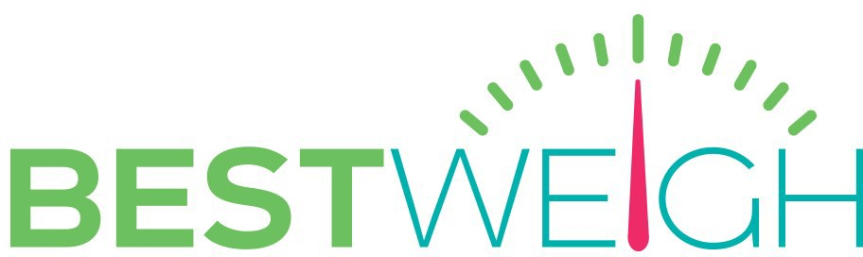LECTURE TOPICS



Online Registration harrisonchurch.com

**Locally Sponsored by the Harrison Seventh-day Adventist Church**

**8419 Hwy 58,**

**Harrison, TN 37341**

**Register NOW harrisonsdachurch.com**

**NUTRITION AND WEIGHT LOSS PROGRAM**

Best Weigh is so Unique! Exercise—How much?

More Motivation for Weight Loss Cholesterol, Good & Bad Fats Low Carb? High Carb?

Protein Myths and Gluten Issues The Best Fruits & Vegetables Whole Grains & Probiotics Which Vitamins & Supplements? Who Are The Healthiest People?

*REGISTER NOW!!!!*

online registration at harrisonsdachurch.com

Enrollment limited to the first **30** persons who register for Best Weigh

# BEST WEIGH PROGRAM

We meet for one and a half hours every Sunday evening. You will experience:

1. Confidential weigh-in.

**Best Weigh Nutrition and Weight Management Program**

Overweight and obesity are epidemic in the United States and around the world. Many in this condition wish they could reach the ideal weight they had at a younger age.

Best Weigh is a scientifically sound, sensible way to move you toward your weight loss goals.

Best Weigh does not use

medication, supplements, or a drastic diet to help you succeed where you have only failed before.

Best Weigh is not a fad. Best Weigh has been helping people just like you for over 30 years.

Many thousands have lost 10-30 pounds over the 10 weeks of each program.

1. Scientifically accurate nutritional facts presented by a medical doctor.
2. Motivational keys to weight loss.
3. Prizes each session.
4. Small group nutritional exercises, quizzes and discussions.

# BEST WEIGH STAFF

Your success is enhanced because of our dedicated staff. Best Weigh lectures are designed by Elvin Adams, MD, a specialist in internal medicine. Adams’ relaxed style and experience make even complex medical concepts easy for all to understand. Lectures will be presented by local medical professionals.

You will receive your individualized support in small groups from people just like you who know Best Weigh

first hand. Every question or issue you have will be carefully and fully addressed.

This very personalized help will go a long way toward making weight

management easier for you than it has been in the past.

**Register Now!!**

**Online registration at harrisonsdachurch.com Enrollment limited to 30 persons.**

# BEST WEIGH SCHEDULE

Best Weigh meets each Sunday evening for 10 sessions starting at 6:00 pm and ending at 7:30 pm. This program

begins on **January 29, 2023** and

concludes on **April 2, 2023** BUT help and counsel are available to you 24/7 throughout the 10 weeks.

**BEST WEIGH COST**

The entire program is yours for the complete and total price of **$20.00.** You will receive:

1. **A 100+ page Workbook.** This is a 3 ring binder in which exercises, quizzes, recipes, and graphs are added each week.
2. **Progress Cards.** Each week you get a new score card to record seven daily health practices.
3. **Personal Weight Loss Graph**
4. **Weekly Prizes**
5. **Diploma on Graduation**



YOUR TOTAL INVESTMENT IS:

$20.00